ks



**Technical Proposal**



**Emirati School Smart Learning Ecosystem**

**Amendment to the existing contract no 1090441 of 2019**

*Submitted to*



**Ministry of Education, UAE**

**Version 5.0**

**10/20/2020**

**Reference: OPP/2020/5/2772**

**Statement of Confidentiality**

All information in this document is ATC Privileged and Confidential.

The information is intended solely for the use of Authorized recipients. If you are not the intended recipient, or the intended recipient’s Agent, you are prohibited from reading, using, disseminating, distributing, and/or copying this document.

In accessing the document, the reader warrants that the information contained herein will be treated as confidential and that no content of any nature will be shared with any other party or unauthorized recipient.

ATC is a registered mark and the ATC logo is a trademark of ATC. ATC is an equal opportunity employer and values the diversity of its people.

Product names referenced herein are trademarks of their respective companies. Many of the designations used by manufacturers and sellers to distinguish their products are claimed as trademarks. Where those designations appear in this document, and the editorial staff was aware of a trademark claim, the designations have been printed in initial capital letters.

**Revision History**

|  |  |  |  |
| --- | --- | --- | --- |
| Document Version # | Approval Date | Modified  By | Section, Page(s) and Text Revised |
| 1.0 | 10/20/2020 | ATC | Initial Submission |
| 2.0 | 15/07/2020 | ATC | Re-submittal. |
| 3.0 | 19/07/2020 | ATC | Updated after feedback. |
| 4.0 | 19/08/2020 | ATC | Updated after feedback |
| 5.0 | 29/09/2020 | ATC | Removed Adaptive Learning and Gifted and Talented as requested by MOE |
| 6.0 | 20/10/2020 | ATC | Updated delivery dates due to delay |

**Contact Information**

|  |  |
| --- | --- |
| Principal Contact Officer’s Full Name | Rohit Suresh Save |
| Position Title | Sales Account manager |
| Telephone Number | +971 (2) 614 7044 |
| Fax Number | +971 (2) 444 4598 |
| Mobile | +971 50 622 4303 |
| E-mail Address | rohit.save@atc-uae.ae |

# Table of Contents

Table of Contents 3

1 Executive Summary: 6

2 Introduction: 7

**2.1** **Al Manhal Overview:** 7

**2.2** **WinjiGo Overview:** 9

3 Part I Emirati Educational Ecosystem Response: 11

**3.1** **Our Understanding of Requirements:** 11

**3.2** **Solution Overview:** 11

**3.2.1** **Approach:** 11

**3.2.2** **Business Analysis:** 13

**3.2.3** **Data Model and Data flows:** 14

**3.2.4** **Design:** 15

**3.2.5** **Development:** 15

**3.2.6** **Implementation:** 15

**3.3** **Integration Overview:** 16

**3.3.1** **Al Manhal and WINJIGO Integration:** 16

**3.3.2** **WIDS Integration:** 20

**3.3.3** **HR Systems Integration:** 20

**3.3.4** **Assessment Integration:** 21

**3.3.5** **TIBCO Integration:** 21

**3.4** **Solution Architecture - Ecosystem Integration Architecture:** 23

**3.4.1** **Data Synchronization (Al Manhal and WINJIGO):** 23

**3.4.2** **User Experience:** 24

**3.4.3** **Infrastructure Requirements:** 24

**3.4.4** **Data Synchronization (with other systems):** 24

**3.5** **Fulfilment of Requirements:** 25

4 Part II Learning Management System Container Response: 30

**4.1** **Our Understanding of Requirements:** 30

**4.2** **Solution:** 30

**4.2.1** **Proposed Interoperability Standards:** 30

**4.3** **Fulfilment of Requirements:** 35

5 Part III Gifted and Talented Response: 42

6 Part IV Adaptive Learning Response: 43

7 Part V Response: 43

**7.1** **Non-Functional Requirements:** 43

8 Project Milestones: 45

9 Dependencies, Risks & Assumptions: 48

**9.1** **Assumptions:** 48

**9.2** **Dependencies:** 48

**9.3** **MOE Responsibility:** 49

**9.4** **Prerequisites:** 49

**9.5** **Risks:** 50

UAT & Warranty: 52

10 Conclusion: 53

11 Company Profiles: 55

**11.1** **Profile – Advanced Technology Consultancy:** 55

**11.2** **Profile – SECOND STEP:** 62

**11.3** **Profile – ITWORX EDUCATION** 63

**11.3.1** **ITWorx Education Solutions and Services:** 63

|  |  |
| --- | --- |
| Date: 10/20/2020 |  |

**Ministry of Education**

Dubai, U.A.E

**Subject: Technical Proposal – Emirati School Smart Learning Ecosystem**

Dear Sir,

ATC in strategic partnership with Second Step and ITWorx would like to express our sincere gratitude to **Ministry of Education** for entrusting us with this opportunity to submit this technical proposal towards your above-mentioned requirement. **ATC is an “Exclusive Local Partner” for Second Step & ITWorx in UAE**.

With high hopes and confidence, we are inclosing the below proposal to meet your requirements. We look forward to working with **Ministry of Education** in providing our best services at all times.

Should you require any additional information or clarifications, please do not hesitate to contact us.

Sincerely yours,



**Rohit Suresh Save**

Mobile: +971 50 622 4303

Email: rohit.save@atc-uae.ae

**Advanced Technology Consultancy LLC**

Commercial Reg. CN-1173831

1st Floor, Khalifa City Trading Centre, Street No. 54, Khalifa City A,

P.O. Box: 145581, Abu Dhabi

United Arab Emirates

TEL: +971 (2) 614 7044, / Fax +971 (2) 444 4598

# Executive Summary:

Advanced Technology Consultancy LLC (hereafter referred to as ATC) wishes to thank Ministry of Education for the opportunity to submit our technical proposal for the Emirati School Smart Learning Ecosystem. We fully understand the importance of providing an unprecedented solution and with the required deliverables have embraced the work and are approaching this opportunity with utmost care and professionalism.

ATC has exclusively partnered with Second Step Software Development (Second Step) for the given opportunity in order to present a viable solution and present this Technical Proposal for ‘Ecosystem Phase 1 Integration’.

With a view to harnessing the potentials of digital technologies in the service of education in UAE, we propose to further enhance the Al Manhal and Winjigo learning platform and tailor it to satisfy the Ministry of Education needs. The current modules and features which are optimized to serve students, parents, teachers, administrative staff, and education policy makers will be further enhanced/integrated based on the captured requirements.

MOE is seeking to consolidate data to be used for advanced analytics and decision making. The data will be used to utilize artificial intelligence and machine learning for adaptive learning, decision making and individualizing instructions to students. Using Artificial Intelligence to compute learning data, Adaptive Learning can automate student modeling to provide students with individualized learning experiences based on their strengths and weaknesses, and support teachers in their day-to-day activity.

The need for distance learning and an integrated platform has increased significantly due to the current COVID Pandemic. It is more critical than ever to provide a full learning platform allowing MOE to offer end-to-end education services to all consumers, namely, MOE staff, students, and parents. The MOE has an innovative and ambitious project of defining and implementing a complete ecosystem for education, which will target all administrative, teaching and learning activities, and will also include employees, students, and parents. This Integration phase continues to target the Ministry, and its representative, in the ability to organize, monitor and control the full education process at all levels. Introducing enhancements to streamline, integrate and share data across core systems. Therefore, allowing in the future to apply big data and artificial intelligence techniques on this information to optimize the entire education organization.

ATC is pleased to have the opportunity to continue to partner with the MOE and to further enhance the Al Manhal, LMs and build the Ecosystem. We are proud to be contributing to the definition of the high level requirements, engaging with the stakeholders, and to be designing and developing the software needed for this prestigious and critical strategic project.

# Introduction:

One of the UAE’s highest priorities has always been education. As President His Highness Sheikh Zayed Bin Sultan Al Nahyan, founder of the UAE, noted, “The greatest use that can be made of wealth is to invest it in creating generations of educated and trained people.”

The UAE has focused on educating both men and women. In 1975, the rate of adult literacy was 54 percent among men and 31 percent among women. Today, literacy rates for both genders are close to 95 percent.

New initiatives are being launched at all educational levels. A key area of focus has been to transform K to 12 programs, to ensure that UAE students are fully prepared to attend universities around the world and compete in the global marketplace. In addition, some of the world’s best universities are creating programs in the UAE, attracting talented students in the Arab world and globally.

The UAE’s commitment to education has helped the nation diversify its economy and prepared a new generation of young people ready to compete in the global marketplace. Part IV

Education four has four main characteristics which known as 4C’s. The education process must follow a comprehensive approach that can provide the Education 4.0 (4 C's) characteristics in a seamlessly integrated environment. The 4C’s are:

* Critical Thinking: finding solutions for problems.
* Creativity: thinking out of the box or even with no boxes.
* Communication: conveying ideas.
* Collaboration: working with others.

As part of MOE continuous goal in empowering educators and students with tools and systems, MOE introduced the idea of an ecosystem. The aim of the MOE is to facilitate and provide a better student centric learning experience, considering the challenges and the difficulties the educators and students are facing to finish their tasks across multiple systems with the objective of providing a better user experiences independently of the multiple systems working behind the scenes.

## **Al Manhal Overview:**

Al Manhal system considers the importance of education in the UAE and can be summarized in providing value in the following main areas:

* Enhancement of the Core Foundation for Education
* Critical Modules Development and Enhancement
* Enhancements for Operational Efficiency
* Replacement of Legacy Application
* Ongoing Changes Requests and Operational Updates
* Single Platform for Schools
  + Multiple Curriculums
  + Multiple Education Types
* Stage Delivery of New Functions/Features

The MOE Student Information System (SIS) Al Manhal was systematically rolled out to replace the legacy SIS to:

* Enhance the processes which support MOE’s business;
* Lay the foundations for the platform for the future Education Ecosystem including the basis for future big data and analytics.

The system addresses different types of users, and has modules and features optimized for each user. The implementation included of many core education modules and features, including but not limited to the following:

|  |  |
| --- | --- |
| * School structure * Enrolment and registration * Course Plans * Assessment (multi-curriculum) * Examination module * Gradebook * Scoring * Report Cards * Timetable * Khalifa Foundation * Children of Martyrs * Homerooms management * Staff Management * Field Survey * Special Needs | * Attendance (Daily and Period attendance) * Activities * Transportation * Communication * Dashboard * Finance * Behaviour * Next Year Simulation * Child Protection System * Pass/Fail * Curving * Online Registration * After School Support |

It provides integration with several MOE core components including:

* LMS for provisioning accounts and data related to student, classrooms and teachers records
* SSO
* Family bundle
* ACTVET tools
* Timetable scheduler
* Emirates ID reader
* Swift Assess
* Alef

The core users include:

* Teachers
* Students
* Administrative staff at all levels of schools and Ministry
* Parents

Together with workflow system, dashboards and reporting across many levels, these functions make the SIS a critical MOE system. All of the above are designed and have been demonstrated to scale.

## **WinjiGo Overview:**

WinjiGo is a unique learning platform that draws upon user interface experiences common in social networks, bringing both familiarity and comfort to users. Simple and intuitive, WinjiGo allows educators to quickly incorporate the use of social learning within the classroom. Designed with student centric approach, WinjiGo interface can be easily understood by the learners allowing them to focus on the learning not on the tools. Different on-boarding techniques are applied to take educators and learners step by step through the educational journey of the system with all its features giving them hands on experience with the solution breaking down the barrier of technology use.

WinjiGo, a social learning platform designed for next generation teaching and learning. It enables different teaching strategies like flipped, blended and inquiry-based learning, and provides teachers with gamification tools and foster learners’ skills and address their specific needs within a fun educational environment.

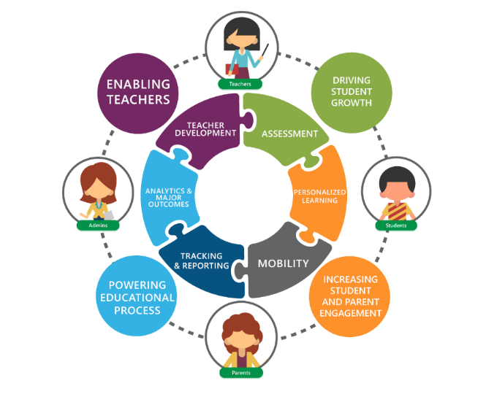WinjiGo connects instructors and learners and supports instructor-led and non-formal learning activities. With leaderboards, assignments, discussions, interactive lessons and individual learning paths, the platform is a great way to tackle teaching space dynamics that can otherwise hold learners back.

WinjiGo helps the Educational process stakeholders

Student: Study anytime, anywhere with simple and easy learning tools, game-like learning experience with easily contact with teachers and colleagues

Teacher: Easy lesson planning tools that increase learners’ engagement, with different ways to measure students’ progress

Parent: continuous children progress follow-up, with open communication channels with teachers and school management.

**WinjiGo** Key **Differentiators:**

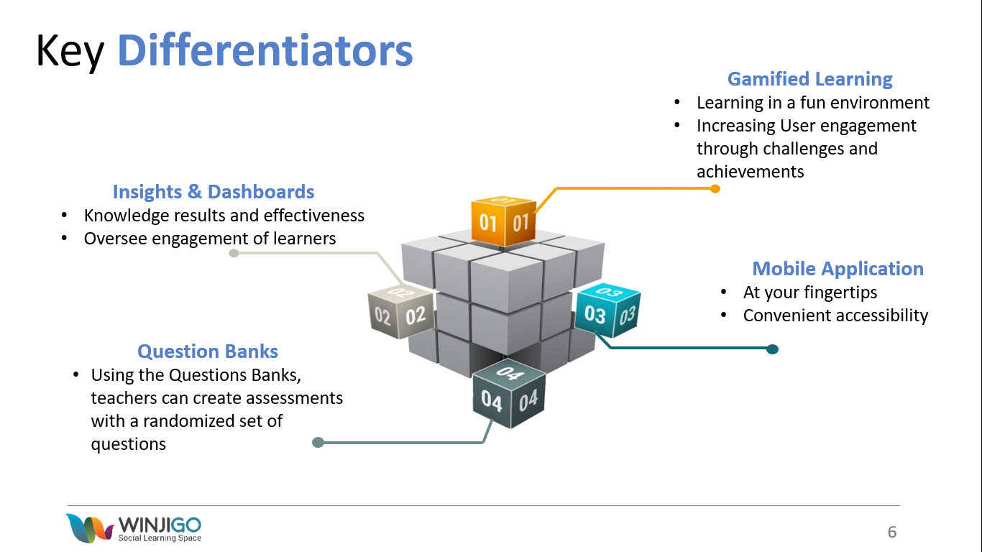

# Part I Emirati Educational Ecosystem Response:

## **Our Understanding of Requirements:**

The need for distance learning and an integrated platform has increased significantly due to the current COVID Pandemic. It is more critical than ever to provide and full learning platform allowing MOE to offer end-to-end education services to all consumers, namely, MOE staff, students, and parents.

The MOE currently has many systems whilst they are specialized and deliver against a specific set of business needs, they are disparate with limited integration and very different user experience.

The MOE has embarked on an innovative and ambitious project of defining and implementing a complete ecosystem for education, which will target all administrative, teaching and learning activities, and will also include employees, students and parents. This Integration phase continues to target the Ministry, and its representative, in the ability to organize, monitor and control the full education process at all levels. Introducing enhancements to streamline, integrate and share data across core systems. Therefore, allowing in the future to apply big data and artificial intelligence techniques on this information to optimize the entire MOE education organization.

By creating and implementing an integrated and interconnected ecosystem this allows the MOE to deliver a holistic learning experience and:

1. Centralize accounts and standardize on the use of SSO.
2. Define the functions and the source systems with integration of the required data between systems and improving the user experience.
3. Define the source system and owner of data to be replicated in a master repository providing a single source of truth.
4. Unifying the system and the data allows improved visibility and more efficient decision making
5. A unified user experience with segregation by role to help minimize the navigation between systems.
6. A unified database allows to share and consolidate the data coming from all systems. The unified event bus allows to process this data in real time for AI applications to maximize the potential.

## **Solution Overview:**

### **Approach:**

MOE is continuously empowering different personas and roles with tools to facilitate their job and provide a better student centric learning experience. However, as a natural consequence to this aspiration, users are finding it difficult to finish their tasks across multiple systems. Accordingly, MOE initiated a project with the objective of having each user persona/role access a single to perform most of his activities independent on the systems working behind the scenes.

The core systems considered in the scope of the Ecosystem Phase 1 integration are the following MOE current systems:

* Student Information System (Al Manhal)
* Learning Management System (WINJIGO)
* HR System (Bayanati)
* WIDS
* Assessment System
* Microsoft Teams

Second Step and ITWORX Education embarked on an intensive study of WinjiGo the core learning platform for teaching and learning, and Al Manhal the core student information management system for MOE. The outcome of this study and the proposed integration scenario is detailed in the following sections. This integration will be based on the 3 mechanisms employed in different use cases to provide a world-class user experience.

* Backend Data Synchronization
* API Integration
* UI Views Loading

The proposed approach also paces the implementation and roll out to 2 phases based on their priorities to the users as follows:

* Phase 1:
  + Master Data Synchronization-Phase 1
  + Timetable Synchronization
  + Behavior
  + Attendance
  + Gradebook
* Phase 2:
  + Master Data Synchronization-Phase 2
  + Announcements
  + Notifications
  + Surveys
  + Events and Calendar

The overall approach is broken down into the following streams:

* Business Analysis
* Data Model and Data flows
* Design
* Development
* Implementation

Each of the above streams are described in more details below:

### **Business Analysis:**

The business analysis stream comprises of the following main steps:

* Analyzing the candidate system and decomposing them into their respective functions and features.
* Determining the roles and frequency of the actors that are using the functions and features.
* Studying the usage and features and determining the correct distribution (by system) based on role.
* Determining the use cases that to be covered in the Phase 1 integration.
* Defining a common authority matrix via the following steps:
  + Map the users in the different systems (identify which users are declared in different systems, and how we can know they are the same).
  + Map the profiles (check the different profiles defined, and identify which represent the same users.
  + Identify the access rights that may be given in the different systems, and identify those that are common.
  + Check consistency between the current profiles in the different systems, and the access rights attributed to each.
  + Resolve access rights inconsistencies (if required) with business owners.
  + Reorganize access rights in systems.

The deliverables from this stream are the following:

1. Functions and Features (by system and role)
2. Use Cases for inclusion in Phase 1
3. Updated Conceptual Diagram (for Phase 1 use cases) – indicating the new proposed business process. Outlining the distribution of the use cases and the system that will be used for the new “to-be” processes.
4. Common Authority Matrix
5. Conceptual Diagram Description Document - describing in details the “to-be” business processes. A sample diagram is indicated below:

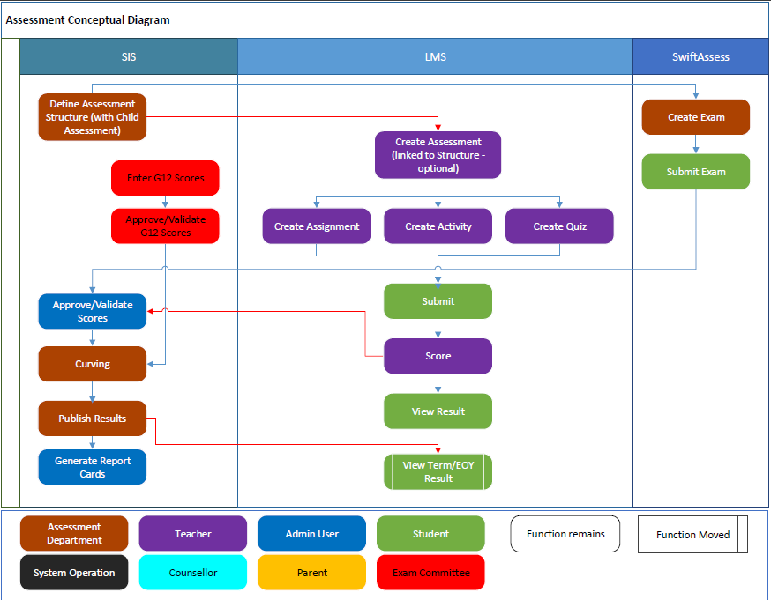

### **Data Model and Data flows:**

This stream is intended to focus in the data models used by the systems in scope and determine the data flow that will be required for phase 1 of the Ecosystem. Note the initial analysis will focus on phase 1 whilst also considering the overall requirements for subsequent integration.

The Data Model and Data Flows stream comprises of the following main steps:

* List the Data domains and Entities of each of the target systems:
  + Al Manhal;
  + WINJIGO;
  + WIDS;
  + Assessment ;
  + HR Systems.
* Identify the shared data between the systems in scope and find the data model overlap.
* Determine the data distribution amongst the systems with the following key considerations:
  + What data flows between the systems;
  + What system should be considered the “Owner/Source” of the data?

The deliverables from this stream are the following:

* Domains and Entity List for Each system.
* Data flows between systems.

### **Design:**

This stream details both the UI and technical design needed in order to deliver the phase 1 integrations. The Design stream includes the following main steps:

* Design function distribution strategy;
* Design data synchronization and provisioning strategies;
* Design sign-in for platform components;
* Design the UI interfacing mechanisms and APIs;
* Design the messaging and data synchronization mechanisms.

The deliverables from this stream are the following:

* High Level Design (Technical)
* Low Level Design (Technical – to include the interfacing mechanisms and APIs)

### **Development:**

This stream is focused on the development and coding activities. The main activities in this stream include:

* Development of the UI components;
* Development of a general messaging model;
* Development of the messaging and data synchronization mechanisms;
* Development work for the integration components, (APIs and exchanging), also the integration work required for the integration with the to-be MOE ESB.

The deliverables from this stream include the following:

* Integrated UI components;
* Messaging and Integration.

### **Implementation:**

The main objectives of the implementation stream are to:

* Ensure a smooth transition to the new Integrated system;
* Ensure the required infrastructure is in place;
* Ensure schools and users readiness;
* Ensure organizational readiness;
* Ensure knowledge transfer and training conducted;
* Ensure future vision is known and communicated;
* Timely and effective communications.

To meet these objectives this stream will focus on the following main tasks:

* Analyze new system infrastructure requirements;
* Implement system infrastructure requirements;
* Execute integration and system tests and conduct UAT;
* Define change management strategy;
* Define Communication and Rollout plans.

The deliverables from this stream include the following:

* Test Cases and Test Scenarios;
* Change Management Plan;
* Communication Plan;
* Training Plan;
* User Manuals
* Rollout/Deployment Plan.

## **Integration Overview:**

### **Al Manhal and WINJIGO Integration:**

Communication between Al Manhal & WinjiGo for the synchronization of the master data will depend on messaging queues. Master Data includes:

* User
* Course
* Class
* Grades & Subjects
* Memberships
* Organization and Schools Hierarchy
* Modifications are only allowed in the system that owns the data, and is synced to the other system, ex: data provisioning (create users, classes, and move users between classes) is only allowed from SIS, and the changes are synced to LMS.

The system will utilize RabbitMQ as the messaging service for the messaging integration system.

#### **Timetable Synchronization:**

The Timetable in WinjiGo will depend on the timetable created in Al Manhal. Data will be synchronized based on the Messaging Integration System. Accordingly, timetable creation and updating will be disabled from WinjiGo.

Teachers and students will be able to see their timetable and move between different weeks. The timetable will also support different schedules from term to term and will preserve the schedules of the terms.

In order to support the timetables and the attendance - as it is based on the timetable - of students and teachers who move to another class, the system will maintain record history of these moves. This history will help maintain the student records (ex. Assignments, behavior, attendance) of all classes that he was a member of for accurate reporting.

#### **Behavior:**

The behavior module will allow administrator to log behavior incidents from Al Manhal as this is the system recommended for them based on the user journey design. On the other hand, teachers will log behavior from WinjiGo based on the business rules defined in Al Manhal. On the UI level, WinjiGo and Al Manhal will integrate to load the behavior view within WinjiGo. From a backend perspective, the data will be directly recorded in Al Manhal Database.

However, to ensure that teachers and students can capture insights related to behavior, Al Manhal will send the recorded behavior, through the use of Messaging Integration System, to WinjiGo to accurately display those insights to the different users interacting with WinjiGo.

Teachers will also be able to view and record behavior incidents from their iOS and Android mobile applications. Integration will be based on API. Students and Parents will be able to view the behavior logged to them/their children based on the business rules defined in Al Manhal. Accordingly, WinjiGo mobile application will build the UI layer that calls Al Manhal APIs to record and view data.

In the mobile applications, teachers will be able to view the records after Phase 1; however, in later phases, teacher will be able to record the data as well.

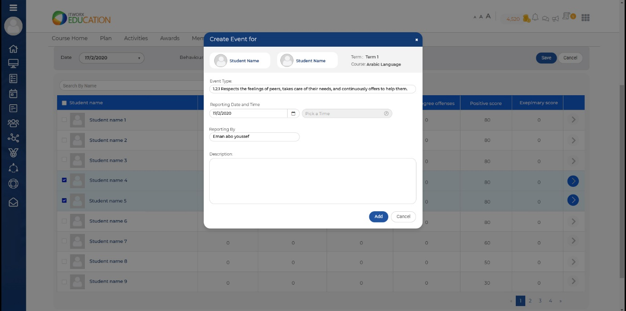

Figure 1: Behavior

#### **Attendance:**

MOE supports two (2) modes of operation in taking the attendance:

* Daily Attendance
* Period Attendance

The daily attendance is typically recorded by an administration role. Based on the user journey design, the administration roles will interact with Al Manhal. Accordingly, WinjiGo will disable its attendance module in case of the daily attendance. However, to ensure that teachers and students can capture insights related to attendance, Al Manhal and WinjiGo will synchronize the attendance data to accurately display those insights to the different users interacting with WinjiGo.

On the other hand, period attendance is either taken by teachers in their classrooms or by an administrator responsible for this recording. Accordingly, the teacher will be able to log attendance in his course in WinjiGo and the admin will be able to do the same through Al Manhal.

On the UI level, WinjiGo and Al Manhal will integrate to load the attendance view within WinjiGo. From a backend perspective, the data will be directly recorded in Al Manhal Database.

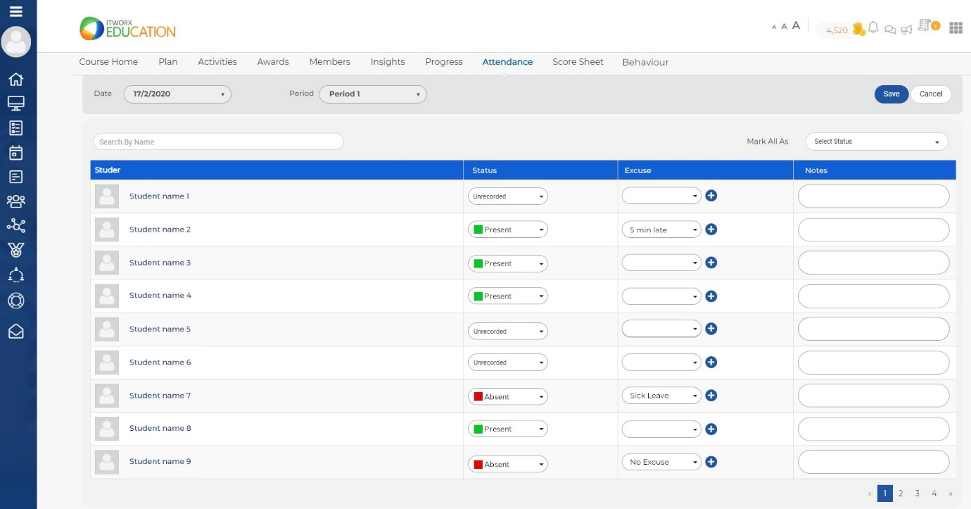

Figure 2: Taking Attendance

Teachers will also be able to view and record attendance from their iOS and Android mobile applications. Students and Parents will be able to view the attendance logged to them/their children. Integration will be based on API. Accordingly, WinjiGo mobile application will build the UI layer that calls Al Manhal APIs to record and view data.

In the mobile applications, teachers will be able to view the records after phase 1; however, in later phases, teacher will be able to record the data as well.

#### **Gradebook:**

The Gradebook's assessment structure is designed by the administration roles within MOE where the administrator sets the different grading categories, gradable items and their respective weights. For continuous assessment, the teacher is conducting assessments and giving students assignments to assess their knowledge of the curriculum they are studying.

Accordingly, the administrator will define the assessment structure in Al Manhal. The teacher will be able to view the assessment structure based on the permissions and different business rules in the LMS to record the scores and link gradable items with assignments that they created and graded. At the end of the grading period (ex. Term), the administrator will publish the scores to the students and only then the scoresheet of the student will be visible to him/her and the parents.

Based on this scenario, WinjiGo will disable the gradebook module and rely Al Manhal to set the gradebook assessment structure. For the teachers, WinjiGo will load a view provided by Al Manhal to record the scores in the gradebook. In order to easily link assessments to the gradebook, WinjiGo will provide APIs for Al Manhal to allow teachers to create this link from within the gradebook page and the system will automatically pass the grades that the students received in the selected assessment to the gradebook. Al Manhal will also provide APIs to WinjiGo to link the assessments directly to the gradebook while the teacher is creating the assessment. This experience provides an easy action path for teachers to complete his tasks in the least possible time.

Teachers will also be able to view the assessment structure and record grades from their iOS and Android mobile applications. Students and Parents will be able to view the grades logged to them/their children. Integration will be based on API. Accordingly, WinjiGo mobile application will build the UI layer that calls Al Manhal APIs to record and view data.

In the mobile applications, teachers will be able to view the records after phase 1; however, in later phases, teacher will be able to record the data as well.

#### **Announcements:**

Announcements are typically created by administrator to send important information based on different rules. Accordingly, administrator will be able to send announcements through Al Manhal and appropriate roles will be able to view the announcement in their interfacing system (i.e. WinjiGo for teacher and students, Al Manhal for administrator roles).

The announcements will be displayed in both web and mobile applications

#### **Notifications:**

Both Al Manhal and WinjiGo includes a notification module. Internal actions that require the user's attention (ex. Assignment created, assignment submitted, etc…). These notifications can be sent to different users' roles (i.e. teachers, students, parents, etc...) in the form of in-app notifications and emails and can be configured either through the administrator or from the user settings.

Al Manhal will send notifications (for teachers, students and parents) to the LMS and the users in WinjiGo will display those notifications in the notification center in both mobile and web versions. Where applicable notifications from LMS will also go to Al Manhal.

#### **Events & Calendar:**

Al Manhal can create activities that are either within the curriculum or extra-curricular activities. These activities can be added to the user calendar view in WinjiGo.

This component will be part of phase 2.

#### **Surveys:**

Both WinjiGo and Al Manhal contains Surveys modules. WinjiGo's surveys module provides multiple question types and a user interface for creating surveys for multiple users and analyzing responses.

The surveys module is not heavily used and will be part of Phase 2.

### **WIDS Integration:**

The Learning Outcomes (LOs) are currently entered in WIDS and are also used in Winjigo in order to align the content to the structure and the learning content. Synchronization/Integration of WIDS and WinjiGo will allow this to be more efficient. The synchronization that will be included is as follows:

* LOs from WIDS to WinjiGo
* LOs from WinjiGo to EduShare

The actual synchronization/integration mechanism to be studied and determined.

For Phase 1 Learning Objects and required WIDS data will be through tools to import using Excel or similar. Phase 2 will include full integration. Note the WIDS integration will be executed via Part II.

### **HR Systems Integration:**

Bayanti (and the HR Systems) contain information on staff and updates are made to staff records etc. directly in HR systems. It is considered that the HR system will be “source” system in this regards. This data will be integrated with Al Manhal which in turn will update WinjiGo. The exact data the mechanism is not known at this moment, however if the MOE ESB is in place in sufficient time we will use the MOE ESB. Details to be captured and agreed during the analysis and design.

### **Assessment Integration:**

Al Manhal has an existing mechanism to take input data (scores) from SwiftAssess. This integration will be studied to automate this integration where possible. The exact mechanism is not known at this moment, however if the MOE ESB is in place in sufficient time we will use the MOE ESB. Details to be captured and agreed during the analysis and design.

### **TIBCO Integration:**

The MOE has a project to use TIBCO as a central mechanism for the integration of all its current and future systems, as well a mean to build a unified database gathering information from different sources, linking it together, ensuring its consistency, and making it accessible to powerful Business Intelligence and Data Mining tools.

In regards to this project, both Al Manhal and WinjiGo are important sources of information. They own important and complementary data, and they generate a lot of transactions and events related to this data. This includes schools and other organizations structure, staff, students, curriculums, teaching and learning events, academic and non-academic results, attendance, behavior, motivation, progress, communication, etc.

It is thus important that both Al Manhal and WinjiGo fully take part in this project with TIBCO. This is materialized through different initiatives:

#### **Design of a Unified Data Model**

TIBCO is to include a central unified database that gathers pieces of information from different sources and links them together. The Ecosystem data model is a subset of the full Unified Data model, which is yet to be developed in the MOE. As the MOE TIBCO project is not expected to be compete prior to the completion of Phase 2, The unified data model for the Ecosystem will be considered to be built initially with a view to later include the same model inside the larger TIBCO model. The built Ecosystem data model will consider the need to capture data on school, student and teacher allowing the MOE to use their TIBCO toolset to provide a 360 degree view of these objects. A correspondence between the data models of Al Manhal, WinjiGo and the unified database will be built. This shall ensure the completeness of the unified model, by incorporating in it any relevant concept of Al Manhal or WinjiGo databases. It shall also ensure its consistency by preventing duplication of data, and establishing relationships between pieces of information wherever suitable.

An important part of the work will be the definition of rules to validate any incoming information, in order to build a clean and consistent *Golden Record* for each entity of the unified database.

#### **Design of an Event Bus**

The unified database is particularly useful for giving a clean and consistent static view of the current status of data. However, in many tools and algorithms require a real-time or close-to-real-time notification of changes occurring to this static view. In addition to a static data model, it is thus important to build an event/messages model, each event representing a change in the data, and is represented itself by a message which gives the essential information about the event and the data change.

The messages have to be consistent with the static unified data model, and cover all the important changes that may occur. The system should typically generate messages for administrative events such as student registration, student promotion, absence detection, etc. It should generate messages for teaching and learning events, such as access to a learning content by a student, mastering of a new learning outcome, participating in an activity, etc.

While the technical aspects of the event bus will be managed by TIBCO, the design of the events and their corresponding messages will involve both Al Manhal and WinjiGo, in particular for the messages that will be generated by these systems, but also for the synchronous or asynchronous messages that these systems will be able to receive and react to. This is an important brick for the integration of multiple external systems, such as systems used by private schools.

#### **Implementation of ESB Connectors**

Based on the definition of the unified data model and of the messages of the event bus, connectors will be developed to fully integrate Al Manhal and WinjiGo to the TIBCO ESB. These connectors will be used in one direction to notify and update other systems about changes happening in Al Manhal and WinjiGo, one of these systems being the unified database itself. They will be used in the other direction to provide a single integration point for all systems that wish to pull or push information from Al Manhal and WinjiGo.

## **Solution Architecture - Ecosystem Integration Architecture:**

### **Data Synchronization (Al Manhal and WINJIGO):**

Current integration between Al Manhal and WinjiGo is one way (from Al Manhal to WinjiGo) and is dependent on manual trigger.

The proposed integration solution is based on a messaging architecture that allows two-way communication between the systems, and near real time processing of events. The systems will exchange business events via a message broker "RabbitMQ".

Data flow:

* Change is made in one system (ex: new user is added in SIS)
* An event is fired from source system, and is added to the event queue
* Consumer will pick the message, and try processing it
  + In case of transient failure, message will be retried with exponential back-off up to 10 times. Any failed message due to missing dependency, will be retried; this allows processing messages regardless the order of generation.
  + In case of non-transient failure (ex: violating business rule), or exceeding the maximum number of retries, message is moved to dead letter queue, and notification is sent to the producer of the event.

The following diagram shows a representation for event flow from Al Manhal to WinjiGo.

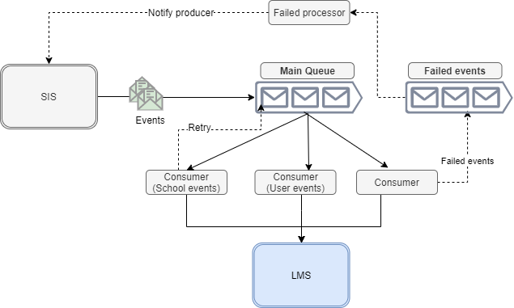

### **User Experience:**

To fulfil the need of having each user persona/role access a single platform, the main system used by each role should allow him to perform his common tasks without navigating to a different system. For example, teachers (currently) mainly use the learning platform, WinjiGo, however, to set gradebook score they will use Al Manhal SIS. In this case, WinjiGo should allow the teachers to use Al Manhal's gradebook module from within the WinjiGo.

To provide this functionality, one of the following integration solutions will be used (to be determined during design):

* Embedded View- View of one system is embedded in the other as an Iframe and styled to match its experience.
* API Integration- Mainly used for mobile applications, and for scenarios that have small business logic.
* Data Sync - Data is synced from one system and displayed in the other system (this is already partially in place), ex: timetable is managed by admins in SIS, and synced to LMS, and displayed to teachers in LMS.

### **Infrastructure Requirements:**

* Allow communication between WinjiGo and Al Manhal on the network level,
* Al Manhal to have access to the RabbitMQ cluster.

### **Data Synchronization (with other systems):**

For integration with other systems (WIDS, SwiftAssess, Bayanti) we propose different integration models, and the best will be used based on availability in each system, these models include:

Messaging

Web API

Database access

We will use MOE ESB whenever possible in order to reduce one to one coupling, however this requires that the MOE ESB is live prior to the integration go-live and to allow time for sufficient level of testing. The communication can be push (producer sends a message or calls a function) or pull (consumer calls a function, or accesses data).

## **Fulfilment of Requirements:**

The complete Ecosystem offers the below holistic Technical, User and Pedagogical Views:



The table below indicates how the Ecosystem fulfils the requirements of the MOE:

|  |  |
| --- | --- |
| Requirement | Solution |
| Provide relevant information in appropriate time, regardless of the available information system | Regardless of the information source, the information is sent through the event bus to any registered subscriber. It is also sent and consolidated in the unified database. |
| Extend functions across multiple systems to support and enrich users experience | Each persona has a main system to use, and all the operations he needs to do are available through this system. The impact of the operations is automatically transmitted to other systems, so that users of all systems can work in collaboration. |
| Consolidate and provide master data management, which reflects the single point of truth and consistent information throughout the multiple systems | Data ownership is established, and all systems are relying on the same source of data. A golden record is built for each entity in the unified database. |
| Provide strong bases for applying artificial intelligence and machine learning due to the consolidation of data, which can be used for offline advances analytics or on the fly decision making for transactional systems | The unified database provides a single and consolidated source of information, allowing all kinds of data analysis. The event bus allows for dynamic flow of information, and on the fly decision making. |
| Capture all student records from Birth to lifelong learning to construct a unified student records for the country | The unified database consolidates a lifelong learning record, gathering information from different systems. Al Manhal covers different types of organizations and learning facilities, allowing to collect data from birth to lifelong. |
| Provide end to end learning and teaching functionalities | All the learning and teaching components are integrated together: SIS, LMS, Assessment, Curriculum, and Content. Also, different content providers and learning models and tools are integrated together within the same LMS. |
| Allow to learn from anywhere and any time | The learning tools are all accessible online. The adaptive learning helps getting the maximum of the learning tools, at the time and at the pace that are suitable for the learner. |
| Utilize AI for adaptive learning and assessment and support personalized learning | Adaptive learning is offered. The integration of multiple content provider as well as adaptive learning solutions allows to get the best available in each domain and for each level, all through a single system. |
| Allow engagement for educators, students, parents, and communities | A single and automated provisioning tool, based on the unified authentication mechanism for all systems, allows all stakeholders to access the system and communicate together as soon as they are declared in the system (educators, students, parents). The changes in the organization are taken into account automatically, allowing to rebuild the communication paths between stakeholders instantaneously. In particular, the integration with Teams ensures that Teams channels are always reflecting the actual communication needs. |
| Support different types of virtual schools | Al Manhal is supporting different types of communities (classes, activities) and of schools (public, private, after school, etc.). Virtual schools can be created easily, and they are reflected directly in the LMS, which will allow distant learning within these schools. |
| Dynamic curriculum & Assessment delivery and access to large collection learning resources | Al Manhal supports different types of curriculum. The integration with WIDS allows for dynamic updates, which are then transmitted to other systems, and in particular WinjiGo. WinjiGo accepts a large range of learning resources, through multiple standard APIs, allowing deep and user-friendly integration. |
| Provide insights that supports decision making by using machine learning to produce predictive and prescriptive analysis of big data | The integration of Al Manhal and WinjiGo to the TIBCO unified database allows to get a single consistent set of data that can be used for decision making. By covering all types of learning, at all ages, the system provides a large set of data, particularly useful for the modern data analysis technologies, such as AI. This is increased by detailed event-based information through the event bus, for fine grain events such as access of a student to a learning resource. The project is offering AI specifically for adaptive learning and for gifted and talented management, but it also opens the door for other AI projects through the consolidation of a huge set of data. |
| Avoid multiple accounts and multiple authentication mechanisms | All systems are relying on MOE SSO for the authentication. Al Manhal is a central piece for the definition of accounts, and is providing the provisioning information to the MOE SSO. |
| Avoid the repetition of functions and data across systems | Each user has a main system to use, and can access the functionalities corresponding to his role through this system. The different levels of integration between the systems ensure that the user gets the data he needs regardless of their source, and that the user’s operations are reflected correctly in all the relevant systems. |
| Avoid not having single and accurate point of truth | By participating to the building of the unified database, Al Manhal and WinjiGo build a single and accurate point of truth, and a golden record for staff, students and all the associated events. |
| Avoid inefficient decision making due to lack of visibility of activities and events | The unified database and the unified event bus ensure that all data is available, consistent, consolidated, and provided in real time. |
| Avoid bad user experience due to the need of navigation from system to system | The operations needed by one persona are grouped in a single system. |
| Avoid limited opportunities to use AI and machine learning to maximize application intelligence across all platforms | The unified database allows to share and consolidate the data coming from all systems. The unified event bus allows to process this data in real time for AI applications. |
| Standardizing the integration protocols between internal and external educational platforms | APIs are defined and unified for the access to the systems (Al Manhal, WinjiGo). The connection to the ESB simplifies the integration of different applications. The support of standard integration protocols by WinjiGo allows to easily integrate a large set of content providers and other educational platforms. |
| Integrated functionality of workflows and functionality at the application level | Each user is interacting with the ecosystem through a single system corresponding to his role. All systems are integrated together to ensure the continuity of workflows between different users (exchange of data, and real-time notifications). |
| Educational content and learning objects | This is provided by WinjiGo through the support of multiple integration standards. |
| Adaptors to provide plugins for application level integration | Al Manhal and WinjiGo are fully integrated with the TIBCO ESB, through the development of the adequate connectors, allowing both data based and event based integration. |
| Ability to add new node for non-MOE and private institutes | APIs are developed in Al Manhal to allow other systems to integrate with, and in particular to upload its own information (enrollments, grading, pass/fail, etc.). Al Manhal can also be used by other institution, with the possibility to handle specific curriculum. |
| Knowledge map for key subjects | WinjiGo can manage learning outcomes, and link them to learning resources and lessons. Knowledge maps can be defined in WIDS and communicated automatically to the other systems through the new integration. |
| Unified data models and databases | The project includes a study of the data model of the different systems, with the ownership of data and the data flow. This can be used as a basis for the definition of the unified data model to be implemented by TIBCO. The development of the relevant connectors ensures that the unified database is populated in real-time with any change coming from any system. |

# Part II Learning Management System Container Response:

## **Our Understanding of Requirements:**

The ecosystem is defined as an interconnected and interdependent network of diverse systems coming together to spur innovation in the tech environment pertaining to products and services in sustainable manner.

Ecosystems include communities that use shared, scalable resources to pursue challenging objectives and common interests. Ecosystems are about dynamic interactions between people, software, data, systems, and services.

All the teams and parties within this consortium has exerted the effort to study the main systems used in MOE to be able to have a clear vision of the required ecosystem. The systems include Al Manhal, the core information management system, and WinjiGo, the core learning platform for teaching and learning. MOE have decided to integrate both systems with other providers and provide one single access for the users to perform most of their activities with a richer user experience.

While achieving an integrated ecosystem that indulges all the current systems and providers in the educational community, all educational entities will achieve promising objectives:

1. **Availability: Provide relevant information in appropriate time, regardless of the available information system**
2. **Usability: Extend functions across multiple systems to support and enrich users experience**
3. **360 data model: Consolidate and provide master data management, which reflects the single point of truth and consistent information throughout the multiple systems**

## **Solution:**

In accordance with the efforts exerted by MOE to achieve the ultimate goal of implementing an educational ecosystem, ITWorx Education team proposition to fulfill a comprehensive and integrated solution between all the systems used within MOE. Accordingly, this section describes the group of standards to be implemented in all the systems to ensure a smooth and reliable integration between MOE systems. ITWORX Education identified four (4) main categories of standards.

### **Proposed Interoperability Standards:**

#### **Content Packaging and Launching Standards:**

This section lists the set of standards which addresses how the content is packaged to enable export and import functionalities of course content between different systems. Also describes how to add supported metadata and curriculum standards related to the content.

Common Cartridge (CC)

The IMS Global Common Cartridge (CC) is a specification that describes format for creating and sharing primarily educational digital content. The specification is developed by IMS Global Learning Consortium and describes in detail the packaging format and infrastructure needed to support format for presenting it to the end-user.

* CC v1.3 will be supported.
* Import CC package into in LMS course.
  + Option to import all or select specific items.
* Export LMS course as CC package.
  + Limited to the supported types in Common Cartridge.
* Item types supported:
  + Non-HTML Files
  + LTI Links
  + Web Links
  + Question Banks
* Question types supported:
  + Question types that is already supported by LMS.
* Metadata supported:
  + All metadata supported and required by LMS.
  + Curriculum standards metadata.

Thin Common Cartridge (ThinCC)

The IMS Global Thin Common Cartridge (ThinCC) is a standard way to enable an evolution to digital curriculum in which the digital curriculum is hosted on a secure web server while being searchable and accessible at a granular level by a learning platform, LOR, or any district system that supports the standard.

* ThinCC v1.0 will be supported.
* Import ThinCC package into in LMS course.
  + Option to import all or select specific items.
* Item types supported:
  + LTI Links
  + Web Links
* Metadata supported:
  + All metadata supported and required by LMS.
  + Curriculum standards metadata.

Questions and Test Interoperability (QTI)

The IMS Global Question and Test Interoperability specification (QTI) defines a standard format for the representation of assessment content and results, supporting the exchange of this material between authoring and delivery systems, repositories and other learning management systems.

* QTI v2.2 will be supported.
* Question types supported:
  + Question types that is already supported by LMS.
* Metadata supported:
  + All metadata supported and required by LMS.
  + Curriculum standards metadata.

Learning Tools Interoperability (LTI)

The IMS Global Learning Tools Interoperability specification (LTI) is an education technology standard developed by the IMS Global Learning Consortium. It specifies a method for a learning system to invoke and to communicate with external systems.

* LTI v1.3 core will be supported.
* LTI Advantage will be supported:
  + Deep Linking v2.0.
  + Assignment and Grade Services v2.0.
  + Names and Role Provisioning Services v2.0.

#### **Information Exchange Standards:**

This section lists the set of standards which addresses the exchange of educational data (students, teachers, courses, enrollments, and grades) between different educational systems.

OneRoster (OR)

The IMS Global OneRoster is a specification solves the K-12 schools need to exchange roster information securely and reliably, course materials and grades between systems. OneRoster supports the commonly used .csv mode for exchange and the latest real-time web services mode known as REST.

* OR v1.1 will be supported.
* Data models supported:
  + Class
  + Enrollments
  + Students
  + Teachers
* Binding models supported:
  + RESTful service model
* RESTful endpoints supported:
  + Rostering (limited to the endpoints listed in the following table)

Table: Supported Rostering Endpoints

|  |  |  |
| --- | --- | --- |
| Service Call | Endpoint | HTTP Verb |
| getAllClasses | /classes | GET |
| getClass | /classes/{id} | GET |
| getAllEnrollments | /enrollments | GET |
| getEnrollment | /enrollments/{id} | GET |
| getAllStudents | /students | GET |
| getStudent | /students/{id} | GET |
| getAllTeachers | /teachers | GET |
| getTeacher | /teachers/{id} | GET |
| getEnrollmentsForClassInSchool | /schools/{school_id}/classes/ {class_id}/enrollments | GET |
| getStudentsForClassInSchool | /schools/{school_id}/classes/ {class_id}/students | GET |
| getTeachersForClassInSchool | /schools/{school_id}/classes/ {class_id}/teachers | GET |
| getEnrollmentsForSchool | /schools/{school_id}/enrollments | GET |
| getStudentsForSchool | /schools/{school_id}/students | GET |
| getTeachersForSchool | /schools/{school_id}/teachers | GET |
| getClassesForStudent | /students/{student_id}/classes | GET |
| getClassesForTeacher | /teachers/{teacher_id}/classes | GET |
| getClassesForSchool | /schools/{school_id}/classes | GET |
| getStudentsForClass | /classes/{class_id}/students | GET |
| getTeachersForClass | /classes/{class_id}/teachers | GET |

#### **Learning Events and Activities Standards:**

This section lists the set of standards related to how students learning events and progress that happens in multiple systems can be reported and stored in a common learning record store for further processing.

Experience API (xAPI)

The Experience API (or xAPI) is a specification for learning technology that makes it possible to collect data about the wide range of experiences a person has (online and offline) and stores these experiences in a learning record store for analysis and processing.

* Design MOE xAPI Profile.
  + Define the vocabulary of verbs, activity types, and template of xAPI statements to be used and what they mean conceptually to get the most out of the xAPI data.
* The ability of LMS to launch xAPI web-based activities using cmi5.
* The ability of LMS to launch xAPI web-based activities using xAPI SCORM Profile.
* Transform xAPI statements to Caliper events when needed.
* Store learning activities in LRS.

Caliper Analytics

The IMS Global Caliper Analytics specification provides a structured approach to describing, collecting, and exchanging learning activity data. Caliper also defines an application programming interface for marshalling and transmitting event data from instrumented applications to target endpoints for storage, analysis, and use.

* Caliper v1.1 will be supported.
* Sensor endpoint to receive events from learning platforms.
* Metric Profiles:
  + Annotation Profile (Optional)
  + Assessment Profile
  + Assignable Profile
  + Forum Profile (Optional)
  + Grading Profile
  + Media Profile
  + Reading Profile
  + Session Profile (Optional)
  + Tool Use Profile (Optional)
* Transform caliper events to xAPI statements when needed.
* Store learning activities in LRS.

Learning Record Store (LRS)

A Learning Record Store (LRS) is a data store system that serves as a repository for learning records collected from connected systems where learning activities are conducted. It is an essential component in the process flow for using the Experience API (xAPI) standard by ADL or the Caliper standard by IMS Global

* Provide LRS for all systems integrating with LMS to communicate the learning activities.
* Learning activities is represented as a set of statements in the form of "Actor Verb Object".
* LRS consists of two main components:
  + API to receive and query the learning activities.
  + Database to store and persist these learning activities.
* LMS to communicate its learning events to the LRS.
* Big data analytics around LRS is out of scope.

Centralized Question Bank

As a part of MOE Vision to have a centralized question banks to include all the item banks from the different sources we propose to develop a central bank as a standalone solution or on top of Edushare learning content management system.

We have include a solution that should support the following Question Types:

* + MCQ
  + True/False
  + Multi-Response
  + Matching
  + Fill In the Blanks
  + Ordering
  + Essay
  + Short Answer
  + Comprehension
* Other capabilities
  + Support Export/Import questions using
    - QTI 2.0
    - QTI 2.1
    - QTI 2.2
  + Support tagging for questions including:
    - Learning outcomes
    - Difficulty level
    - Hints
    - Source/Copyrights
  + Support folders and sub folders

Note the following:

* We assume that the question bank will be populated through export questions from the source to be imported in the bank.
* Teachers and Specialists will need to export questions from the central bank into their LMS bank so they can use it the LMS assessments.
* It is assumed to use the same questions editing capability as per the LMS.

Documentation Deliverables

* Updating existing LMS documentation (whenever needed) including:
* LMS Design document
* LMS Deployment guide
* LMS User guide

## **Fulfilment of Requirements:**

Having the standards supported from WinjiGo's end will need to be complemented by MOE other systems to enable integration. Below are MOE`s systems and, whenever feasible, an overview of the proposed integration scenario.

EduShare

* Unifying EduShare& WinjiGo Master Data:
  + User Identities
  + Grade Levels
  + Subjects
  + Learning Objectives
* Share learning objects easily between EduShare and WinjiGo
* Track and record student's learning activities
* Support interoperability standards in EduShare

Open Education Resources OER

* MOE OER is providing students with content to excel their skills and increase their knowledge.
* LMS shall integrate with this system to be able to grab and include content within the courses and material
* For recommended standards that needs to be supported by Open Education Resources OER please refer to section "LMS recommended integration standards"

SwiftAssess

* SwiftAssess is an assessment management platform, aims to redefine the assessment experience by bringing new dimensions to the way educators author, deliver and track their assessments on daily bases with an outcome-based strategy to empower and understand student progress, measure knowledge intake and evaluate curriculum effectiveness.
* The integration will support export/import questions between LMS and SwiftAssess
* The system will write back the grades to Al-Manhal Gradebook
* For recommended standards that needs to be supported by SwiftAssess please refer to section "LMS recommended integration standards"
* **Assumption:** SwiftAssess supports SSO

FastTest

* Currently MOE users do not have direct access to FastTest and its questions are an intellectual property so it cannot be imported to LMS, accordingly there is no integration point from LMS perspective.

Mc-Graw Hill FROST

* A platform that contains content and activities for students and enrich learning resources offered by MOE to students and educators.
* LMS shall integrate to include content into the courses and material
* For recommended standards that needs to be supported by Mc-Graw Hill FROST please refer to section "LMS recommended integration standards".

McGraw-Hill ConnectED

* A platform that contains content and activities for students and enrich learning resources offered by MOE to students and educators.
* LMS shall integrate to include content into the courses and material
* For recommended standards that needs to be supported by Mc-Graw Hill ConnectED please refer to section "LMS recommended integration standards".

Mc-Graw Hill ALEKS

* Assessment and Learning in Knowledge Spaces is a Web-based, artificially intelligent assessment and learning system. ALEKS uses adaptive questioning to determine exactly quickly and accurately what a student knows and does not know in a course.
* ALEKS then instructs the student on the topics he/she is most ready to learn. As a student works through a course, ALEKS periodically reassesses the student to ensure that topics learned are also retained. ALEKS courses are very complete in their topic coverage and ALEKS avoids multiple-choice questions. A student who shows a high level of mastery of an ALEKS course will be successful in the actual course she is taking.
* For recommended standards that needs to be supported by Mc-Graw Hill ALEKS please refer to section "LMS recommended integration standards"

Al Diwan

* A software to publish MOE curriculum content like books.
* For recommended standards that needs to be supported by Al Diwan please refer to section "LMS recommended integration standards"

Learnetic

* Learnetic has different systems and products for educators, a combination of a powerful Authoring Tool, content, and eDevelopment Platform dedicated to build highly interactive Digital Resources and to coordinate the workflow of the Project Teams involved in its creation.
* The developed eContent is built along the eLearning industry standards and supports all, desktop, and mobile devices, making it perfect for personalized and technology-supported education. MOE target to integrate with all Learnetic products that are exist in MOE environment.
* eContent should support:
  + xAPI SCORM Profile to report student interactions to the LRS.
  + "Web-Based Activities" xAPI launch mechanism.
* For recommended standards that needs to be supported by Learnetic please refer to section "LMS recommended integration standards"

WIDS

* WIDS is all about curriculum. From designing sound performance-based programs and courses to mapping outcomes and building assessments, the software is to design, align, and manage curriculum. Users can see what they need to consider in curriculum design but can also see the big picture along the way. Multiple template options pull curricular elements into documentation necessary for learners, faculty, administrators, and accreditors. Software roles allow for development, review, and approval of curriculum; never again will faculty or administration wonder what course is current or active.
* Sync LOs from WIDS to WinjiGo
* Sync LOs from WinjiGo to EduShare

ALEF

* The Alef platform provides personalized learning experiences for all students so they learn at their own pace, anytime and anywhere. Artificial intelligence allows students to receive individualized instruction and give them the choice in how they prefer to learn.
* Artificial intelligence allows students to receive individualized instruction and give them the choice in how they prefer to learn.
* The platform provides immediate feedback to teachers about students’ attainment. Teachers can use the data to address specific areas and help students with individual needs.
* To ensure integration, ALEF shall support:
  + SSO
  + Send All learning Events to the LRS

Form LMS side, the below shall be supported:

* + Provide Provisioning data using IMS OneRoster
  + Avail Course Plan structure
  + Avail Learning Outcomes

Boclips

* Make learning captivating with video. Boclips makes accessing the best educational videos simple, seamless, and safe. That way, you get to focus on delivering truly amazing learning experiences.
* For recommended standards that needs to be supported by Boclips please refer to section "LMS recommended integration standards"

Matific

* Math educational platform designed by pedagogical experts, personalized math learning for K-6 students aligned to your local curriculum
* For recommended standards that needs to be supported by Matific please refer to section "LMS recommended integration standards"

Tigtag

* Stunning three-minute science and geography films, Tigtag has everything you need to plan and teach outstanding science and geography lessons for ages 7–11. Tigtag is produced by Twig Education.
* For recommended standards that needs to be supported by TigTag please refer to section "LMS recommended integration standards"

Twig

* Delivering award-winning K-12 science programs that explore real-world phenomena through student-driven investigation and discovery.
* For recommended standards that needs to be supported by Twig please refer to section "LMS recommended integration standards"

Nahla Wa Nahel

* Combine the knowledge of Arabic teachers, with a game-based approach, and challenge students to improve their levels of knowledge, cognitive skills, and memory.
* With more than 1,000 leveled Arabic books from the Middle East’s leading educational publishers, plus thousands of corresponding video lessons and resources that support instruction, foster engagement and critical thinking it is a leading Arabic language reading and comprehension resource for grades K-6.
* For recommended standards that needs to be supported by Nahel wa Nahla please refer to section "LMS recommended integration standards"

Microsoft Teams

* A communication platform by Microsoft that enable a video and voice collaboration and communication between teams, students, and teachers. MOE use MS Teams as its communication platform to deliver distance learning and its employee’s communication.
* API Integration with MS Teams to support adding live lesson from inside the LMS + support bulk provisioning:
  + In order to support teachers and facilitate conducting distant virtual classes between teachers and students, WinjiGo will integrate with MS Teams. From within WinjiGo Lesson Planning component, the teacher has the capability to schedule a MS Teams virtual class. This class will be automatically created within the corresponding MS Teams Channel. WinjiGo will remind the teacher and students that the lecture is starting now by sending a notification to them. Users can join the meeting by click on a button “Join Now” from within WinjiGo.
  + Once the virtual classroom is concluded, users will see a button “View Session” which will take them directly to the recording of virtual classroom where they can find the meeting recording, chat history, the notes and the whiteboard of the virtual classroom. Such integration allows students to go back and revisit the lesson in case they missed parts of it due to network connectivity issue or any reason for absenteeism as well as filling any gaps in understanding.
  + From an administration point of view, WinjiGo will allow the user creating the course, whether from WinjiGo or through the bulk provisioning tool, to create course site/channel in MS Teams that corresponds to the course being created or link to an existing one. Furthermore, WINJIGO will automatically enroll the students and teachers to the same MS Teams Channel. Any further virtual classes created in the course will be created under the corresponding channel in MS Teams.

Virtual Classes Integration

The below Use Cases were recently added to the scope:

* [**Use Case 1**] Enable teachers to copy a link for a document that is hosted in the LMS course plan and paste it under teams' general chat or class team chat in which the students will be redirected to the resource upon clicking on the link.

Note: this apply only on file based resources that is hosted in the LMS

* [**Use Case 2**] if a teacher adds a document during a live session meeting under the class teams, the document should be accessible in the LMS in a separate tab than the course plan for further reference.
* [**Use Case 3**]: Enable the teacher to select a shared document from the class teams onedrive in an handout assignment in the LMS in which a group of students can collaboratively work on the document.
* [**Use Case 4**]: Enable the teacher to add content in the course plan from the Teams OneDrive.
* [**Use Case 5**]: Sync the teams note with the behavior system
* [**Use Case 6**]: Enable the teacher to add an existing assignment from teams to the LMS activities and get the students' scores upon submission/grading.
* [**Use Case 7**]: Add a Chat button under the users cards in the members tabs in the LMS, this button should redirect the user to the chat window on teams web interface.
* [**Use Case 8**]: Push notifications from teams to LMS and from the LMS to Teams
* Assumption: LMS will provide read and write APIs for the notification to be called by MS team
* [**Use Case 9**]: Having a teams app with shortcuts for quick access for LMS modules, we assume this is a pure Microsoft scope
* [**Use Case 10**]: Sync all the file-based resources in the course plans to the files under the teams in which units and lessons will be treated as folders and the learning resources will be added as files under the lesson folder
* [**Use Case 11**]: Enable the teachers to create live sessions on teams from the LMS and display the created sessions for the students so they can join
* [**Use Case 12**]: Automatically record the session attendance in Al-Manhal based on their participating in the live session

Other Requirements:

Synchronize the created Teams sites IDs with the created courses in the LMS assuming that the team sites will be created based on school data sync through integration with Al-Manhal

Assumptions:

* The scenarios are still subject to refinement and subject to adjustment to be compatible with LMS
* Changes in Teams and the other Microsoft products will be fully handled by Microsoft team.
* It is assumed that all those scenarios are supported by Microsoft and Microsoft will provide all the necessary APIs required for those scenarios.
* It is assumed that Microsoft will make sure to record all the learning events that take place inside the teams into the LRS.

#### **LMS Recommended Integration Standards:**

Below is a categorization for the recommended standards that should be supported by any system to facilitate integration with LMS based on typical used cases.

Content that will be hosted in content provider platform (adding/importing content in LMS)

* Use of LTI Deep Linking v2.0 is recommended to provide seamless experience for adding/importing content in LMS.
* Use of IMS Caliper is recommended to capture students learning activities.

HTML interactive content that will be uploaded/hosted in LMS directly

* Use of xAPI SCORM profile or cmi5 is recommended to integrate with LMS to capture students learning activities and interactions with these packages in LRS.

Questions that will be hosted in assessment platform (export and import questions into question banks)

* Use of QTI is recommended to export and import questions into question banks.

Assessments that will be hosted in assessment platform (adding/scheduling assessments in LMS)

* Use of LTI Assignment and Grade Services v2.0 is recommended to provide seamless experience for adding/scheduling assessments in LMS.
* Use of IMS Caliper is recommended to capture students learning activities.

Bulk content import from content provider platform

* Use of CC and ThinCC is recommended to export and import content into courses.
* Use of LTI v1.3 is recommended to launch content linked to external systems.

# Part III Gifted and Talented Response:

Note that this part of the response has been removed at the request of the MOE.

# Part IV Adaptive Learning Response:

Note that this part of the response has been removed at the request of the MOE.

# Part V Response:

## **Non-Functional Requirements:**

|  |  |
| --- | --- |
| Requirement | Response |
| Authentication provider will be MOE Single Sign On Platform | Al Manhal is already relying on MOE SSO. WinjiGo will be modified to do the same. Other systems integrated to WinjiGo through IMS Global standards will use the authentication of the user to WinjiGo, and will not need additional user login. |
| Communication between sub-components should have MOE meta data to enable aggregating objects, activities, transactions, and easy data analysis. | A consistent consolidated data model will be defined, where all entities will have well-defined unique and sharable identification. This will allow aggregation and consolidation of data coming from different data sources. |
| All sub-components should follow MOE standards and meta data provided by MOE. | The project will adhere to the standards defined by MOE. |
| Integration should be done according to latest standards for learning and assessment management and any other sub-components. | Integration will rely on latest standards such as IMS Global LTI and Common Cartridge. |
| Acceptance criteria should be agreed between MOE and providers | Acceptance criteria will be defined at the beginning of the project, through signed BRDs. |
| Users login and email provided by MOE should be used among all different platforms and providers. | Authentication will rely on MOE SSO which is used also by MOE emails. |
| All users’ data should be stored in MOE Learning Resources Store LRS to enable MOE team to do data science operations on the data collected | This is included in the project. |
| Artificial Intelligence platform should be capable to handle extra resources even it is not mentioned in this document | AI Engine is removed at request of MOE |
| Ability to integrate by vendor agnostic concept by providing ready connectors for standardized providers. | Connectors will be designed based on the conceptual data model, and will not be specific to any system to be integrated. |
| Detailed technical and business documentation should be created in each milestone | Technical and business documentation will be provided for the different modules of the ecosystem, and the different milestones. |
| Detailed projects’ plans should be provided for the entire program | A high level timeline is included and a detailed project plan will be agreed at the beginning of the project, subject to award and will be maintained all through the project. |
| Ecosystem should support multi-tenancy and Software Defined Data Center. | The main components of the ecosystem – Al Manhal and WinjiGo – both support multi-tenancy, and allow different private schools and other organizations to use the system. The capacity of the other components of the ecosystem to support multi-tenancy may be variable from one component to the other, and is fully under the control of the component’s vendor.  The main components of the ecosystem – Al Manhal and WinjiGo – will both be deployed in the MOE Software Defined Data Center. The capacity of the other components of the ecosystem to support Software Defined Data Center may be variable from one component to the other, and is fully under the control of the component’s vendor. |

# Project Milestones:

The high-level timelines for each response Part are indicated below:

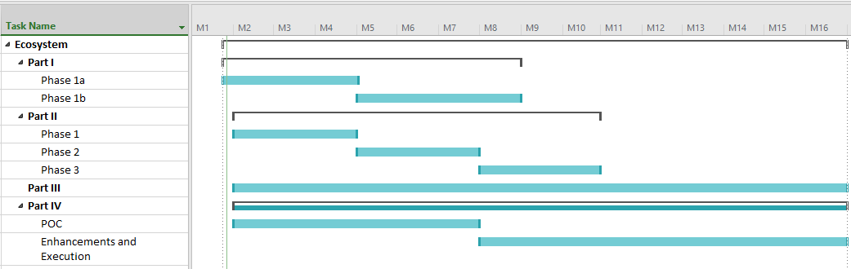

More details can be found in the respective sections and below.

**Part I**

|  |  |
| --- | --- |
| Milestone | Target Month |
| Analysis | **Month 1** |
| Design | **Month 2** |
| **Phase 1a - Development and Implementation** | **Month 4** |
| Master Data Sync – Phase 1 |  |
| Attendance |  |
| Timetable |  |
| Behavior |  |
| Gradebook |  |
| **Phase 1b - Development and Implementation** | **Month 8** |
| Master Data Sync – Phase 2 |  |
| WIDS |  |
| SwiftAssess |  |
| HR Systems |  |
| Survey |  |
| Events and Calendar |  |
| Notifications |  |
| Announcements |  |

**Part II**

|  |  |
| --- | --- |
| Milestone | Target Month |
| **Phase 1** | **Month 4** |
| Support Thin Common Cartridge 1.0 |  |
| Consolidate Learning Events from Various Systems in LRS using xAPI SCORM Profile |  |
| Support LTI 1.3 |  |
| Show Teachers LTI 1.1/1.3 Grading Scores |  |
| **Phase 2** | **Month 7** |
| Support QTI 2.2 |  |
| Support LTI Advantage - Deep Linking Package |  |
| Support Common Cartridge 1.0 |  |
| Support IMS Caliber 1.1 |  |
| Log WINJIGO events based on xAPI SCORM Profile |  |
| Create & Associate Teams from UI & in Bulk Provisioning |  |
| **Phase 3** | **Month 10** |
| Launch xAPI using CMI5 |  |
| Edushare Master Data Unification |  |
| Support CC 1.3 |  |

**Part III**

Removed at the request of MOE

**Part IV**

Removed at the request of MOE

Note that we will target completion of Part I and Part II by end June 2021.

The timelines above outlines high level durations; noting that these are prepared during proposal high level planning and subject to revision once the preliminary schedule phase and an accurate list of project milestones are carried out, detailed revised dates should be available by end of planning phase. These durations and planning are subject to contract award, mobilization, prioritization and availability of resources. These timelines are highly tentative and are impacted by:

* customers prioritization during project kickoff;
* teams` capacity/workload;
* MOE Plans due to interdependencies of projects and deliverables.

# Dependencies, Risks & Assumptions:

## **Assumptions:**

* Only the high-level integration requirements are known at this stage. More detailed sessions and approval from Business Owner and stakeholders is required for a detailed understanding. Any major deviations will be mutually agreed and subject to Change Control.
* Anything that is not explicitly mentioned within this document is considered out of the scope of the proposal (unless later mentioned in the to-be agreed Analysis and Design deliverables). Any additional development, integration and/or migration will be handled as a variation via change control.
* The initial scope of Phase 1 is MOE Public schools.
* APIS will be required for integration to third party systems, these are the responsibility of third party to provide with proper documentation.
* ATC will provide a 30-day initial warranty period post go-live for new functions/features/integration.
* LMS should be configured to use MOE Single Sign On solution
* MOE to provide a service to retrieve users MOE email account (@moe.gov.ae) based on user’s ExternalID (the currently shared Id between MOE & SIS)
* Schools using ITWORX Education LMS should be defined in SIS to enable the SIS to communicate events related to those schools only to ITWORX Education LMS
* All project deliverables and documentations will be in English language. User Manuals and User guides to be provided in Arabic.
* UAT and Knowledge transfer shall be conducted and supported remotely by implementation team.
* Knowledge transfer to MOE team for L1 and L2 level of support
* Platform hardware and software, ITSM tools, licensing and associated costs required for this proposal will be the responsibility of MOE.
* The MOE Service Desk will be the single point of contact for support services for the Ecosystem.
* MOE will provide Level 1 and Level 2 support.

## **Dependencies:**

* LMS should be configured to use MOE Single Sign On solution
* To enable direct communication between LMS and SIS, the intermediate MOE database will be skipped
* Business rules applied to populate this database should be communicated to respect it in the new integration solution
* It is required to get acceptance for all deliverables within three (3) days from delivery date. Delay in approval will be subject to Change Control.
* MOE ESB should be in place for Integration (other than direct integration between Al Manhal and WINJIGO)

## **MOE Responsibility:**

1. All infrastructure related needs for both production and test environments including servers, network devices storage and the monitoring of the infrastructure will be provided by MOE. Network configuration information such as IP addresses, DNS and others will be provided by MOE.
2. MOE IT will provision and build all necessary test hardware and test environments in a timely fashion. Any late delivery/build may result in project delays.
3. Identify all respective Business Owners and decision makers and ensure their availability and project engagement.
4. MOE will appoint shadow Business Analysts in each Part of the project who will assist in the detailed analysis phase for elicitation of detailed requirements, documentation and follow up/ agreement with respective business owners.
5. MOE will be expected to have the designated business users participate in the UAT testing.
6. Ensure that all MOE approvals happen in a timely manner and as per the agreed schedule.
7. All data backups must be done by MOE IT. Second Step can advise on the frequency and the technical needs.
8. Business continuity, disaster recovery, site resilience is the responsibility of MOE.
9. Platform hardware and software, licensing and associated costs required for this proposal will be the responsibility of MOE.
10. System users will be available in order to undertake the necessary training prior to rollout, using a Train the trainer approach via MOE Adoption team.
11. The Adoption Team (or alternate pool of trainers to be provided by MOE), these trainers will be responsible to train the end users that will use the Ecosystem integrated functions and features. Second Step will work with Adoption Team to deliver a reasonable amount of training to help ensure the knowledge. Where possible a progressive implementation methodology will be applied in way that take to account the business need (different schools, education type and different timings) and reduce the impact and the risk on the business.
12. Transformational Change and related change Management will be the reasonability of the MOE. This includes standardization if policy and process between MOE schools (Dubai and Northern Emirates) and Abu Dhabi Schools.
13. Definition and development of the necessary Ministry of Education processes, policies and standards related to Gifted and Talented.

## **Prerequisites:**

* The following are the recommended Infrastructure specifications:

Hardware Requirements (for Integration)

* + - Two servers (8 Core / 16 GB RAM / Windows Server OS)
    - Three messaging servers RabbitMQ (either utilize existing or provide new ones)
    - Additional Al Manhal SIT and UAT instances to be built as per the current al Manhal specifications

Hardware Requirements (for Container Part)

* Learning Record Store (LRS) – HW Requirements
  + - Two (2) web servers
  + Memory: 16 GB, Processor: 8 Cores, Disk: 100 GB
    - Load balancer
    - Three (3) database servers
  + Memory: 64 GB, Processor: 8 Cores, Disk: 100 GB, Disk: 1 TB
  + Network connectivity should be allowed between SIS servers and LMS front-end servers
  + Network connectivity should be allowed between SIS and LMS messaging servers
  + Network connectivity should be allowed between the systems in scope and the ESB.
  + ESB in place with network connectivity and suitable ESB testing environment.

## **Risks:**

|  |  |  |
| --- | --- | --- |
| Risk Description | Suggested Mitigation/Action | Responsibility |
| Users are not suitably ready to use the new system | Training to be given in advance with training materials. MOE and support team are available to give the required information. Key users are identified and Adoption Team plus the service desk are trained and up to speed. | SS |
| Delay in sign-off from business stakeholders | Ensure that all stakeholders are identified early and engaged from the start of project.  Create documentation to help facilitate early agreement. | MOE |
| Users are not on board with new system and already undergoing a lot of changes due to distance learning etc. | Ministry to issue communication with Vision and executive mandate.  Incentives to be offered. Target the positive users/schools as champions. Make some quick improvements from gathered suggestions. | MOE/SS |
| MOE IT staff already heavily utilized on multiple projects and large initiatives. | Need commitment from MOE and fast turnaround of approvals, requests etc. | MOE |
| Since the COVID pandemic a main focus in the MOE is for Distance learning and to onboard additional schools. Therefore Al Manhal target schools is increasing in parallel to new functions being added. This means that both numbers of schools and usage is not fixed which adds a risk. | Needs agreement with MOE on clear scope, numbers of schools etc. | MOE/SS |
| Additional staff are required in order to deliver this scope of work. The current COVID crisis presents a risk that will not be able to onboard. | Work with MOE to prioritize the workload and re-assign resources as required. | SS/MOE |
| Change Management/Transformation Challenges - must be carefully managed during the transformation phase as business will evolve towards entering continuous assessment progressively during the term, | Business processes will need to be updated in particular in tracking the progress of scoring and managing the scores entry by schools. | MOE |
| Staff has to be exactly the same in Al Manhal and LMS, which mean that it will not be possible to define temporary teachers in LMS only. | A practical business process has to be put in place, for instance by adding a “temporary” flag in the teacher record in Al Manhal to allow controlled creation of temporary teachers in Al Manhal, or by to modify the HR process to avoid a period where teacher is not confirmed yet in the HR system, but already joining the school – must be carefully managed during the transformation phase. |  |
| Readiness – Rollout, training and knowledge transfer whilst under remote working conditions. | Make use of Teams and build effective communication plan and training/knowledge transfer. | MOE/SS |

# UAT & Warranty:

For each delivered phase, remote UAT activities shall be conducted. These activities would include:

* + Deployment
  + UAT
  + Stabilization
  + Knowledge transfer to MOE team

UAT and Knowledge transfer are conducted one time in a centralized location. However, for major phases, where possible, we will dedicate an onsite resource to be responsible to conduct the UAT activities onsite. Upon conclusion of the UAT activities the warranty phase will commence.

Warranty

* We will provide 60 days warranty after each major phase where the scope will cover fixing the reported Problems/Bugs related to the following:
  + Failure of the application software
  + Deviation from the functional specification as provided in this scope document
* Deviation from the Requirements Modification are made through Change Requests (CRs)
* Updating documents (Deployment Guide, and Release Note) accordingly
* If needed, MOE team will grant VPN access on the staging & production environments for remote team to reproduce, investigate and verify issues when needed
* Required resources will be dedicated to be responsible for deployment, UAT, stabilization, L3 support for issues related to integration and knowledge transfer to MOE team for L2 level of support.
* During the warranty period, Second Step and ITWORX Education will handle 3rd line tickets through an offshore support team, tickets should be filtered and checked first by MOE support team.
* MOE team will grant VPN access on the Ecosystem staging/support environment for remote support team to reproduce, investigate and verify issues when needed
* MOE will notify in advance of any planned (or unplanned) environment change or application/platform upgrade before applying it.

During the warranty, Second Step/ITWORX Education receives an incident through the Avanti notification or email, Second Step/ITWORX Education technical support team prioritizes and resolves it. If an issue is caused by multiple problems, each problem must be reported separately and grouped by Service Desk. For lower priority incidents where a MOE’s operation is not impacted or if a workaround is arranged, MOE will take the initiative to suggest a lower priority level for the incident reflecting its true level of urgency.

The Incident's response time is assessed according to the priority level set by the customer. If incident assessment is not prioritized by the MOE, Second Step/ITWORX Education technical support team will assign a priority to the incident and conduct an initial investigation to determine problem's scope. Second Step/ITWORX Education technical support engineer updates MOE with incident isolation and resolution progress.

# Conclusion:

This project is an exciting and ambitious project in order to achieve this we determine the critical success factors for the project to include:

* Executive Sponsorship;
* Stakeholders engagement;
* Transparent communication between all parties;
* Sharing and collaboration;
* Resource availability;
* Management of the Critical dependencies including other MOE led initiatives;
* Prioritization of the workload;
* Working as a single cohesive team in order to:
  + Finalize the Ecosystem requirements in order to agree something achievable in the relatively short stage timeframes;
  + Deliver in an aggressive timeline with many inter-dependencies;
  + Collectively overcome challenges and successfully deliver the MOE vision.

Our consortium is very excited at the prospect of continuing our working relationship with MOE in order to deliver the next set of enhancements and elevate both Al Manhal and WinjiGo into an integrated Ecosystem. We thank you for the ability to submit this proposal and to demonstrate once again our joint capabilities and look forward to a long and mutually beneficial business relationship with MOE.

# Company Profiles:

## **Profile – Advanced Technology Consultancy:**

ADVANCED TECHNOLOGY CONSULTANCY ([www.atc.co.ae](http://www.atc.co.ae)) is a local Systems Integrator and solutions provider based in UAE. With presence spread across the emirates and major delivery office in Abu Dhabi & Dubai, we are the preferred partner for Governments, Defense, Education and Healthcare for enabling digital transformation.

When it comes to digital transformation, a few can envisage the inevitable wave of opportunities that it brings. At ATC, we embrace this global change with a vision that reflects on an outstanding track record gained through many waves being that it is an active player in the market and not just an observer. We have witnessed the transformation of e-commerce, e-Gov, smart-Gov and how the disrupted the way the ICT & ITS is perceived by any organization through its unorthodox yet forward thinking model.

ATC is not a **“me too”** player, rather it is nimble boutique inspired by the massive advancement to bring a new business model specifically tailored to its clients focused on IOET, Cloud, AI, and Mobility.

Our offering integrates a complete Cloud stack with infrastructure you need for compute & storage (IaaS), a platform to create your business applications (PaaS) and Cloud Application Services (SaaS) to run applications your business needs by leveraging Cloud, Mobility, AI, IoET and Big Data to better transform businesses.

This means, we can help you navigate through the regional regulatory & compliance landscape with ease & optimize your architecture in return for an affordable pay as you go service. We work with your IT team to securely migrate your data by leveraging the best technology from the biggest names in the industry like Microsoft, DELL, Huawei and Amazon to make sure that your applications are not just secure but highly available to your employees & customers. Our partnerships extend the length & breadth of Technology Portfolio, we combine the expertise of our people, the technology of some of the biggest cloud providers in the world to create a truly unique business proposition for you and your business.

We bring the right pillars to assist decision makers to strive beyond static automation as we place them on equal footage with their global rivals.

* **Our solution framework**

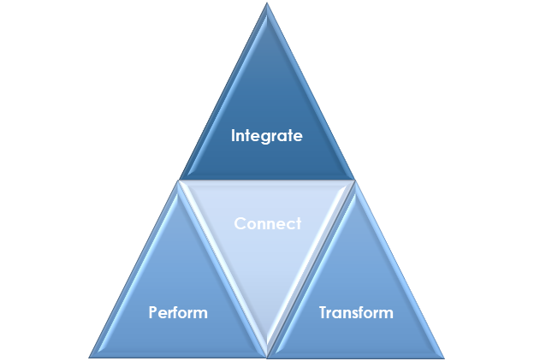

ATC Solution Framework

* **Digital Workplace Solution**

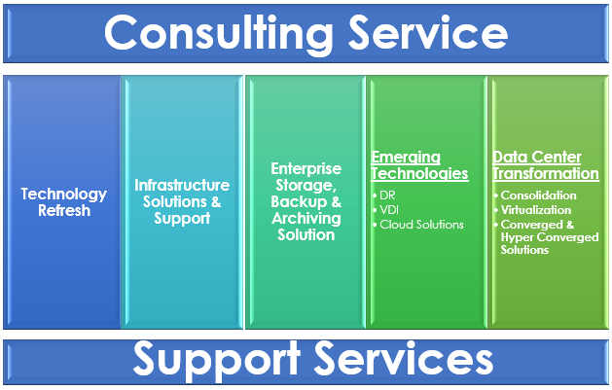

* **Platform Solutions**

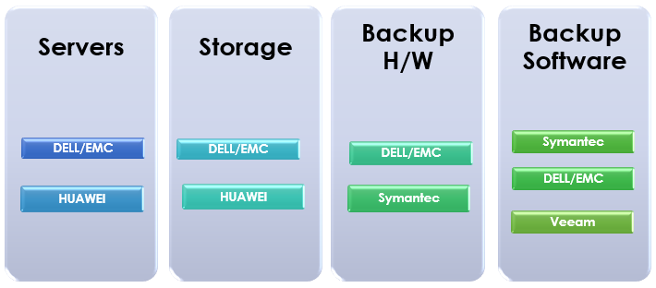

* **Emerging Technology Solution**

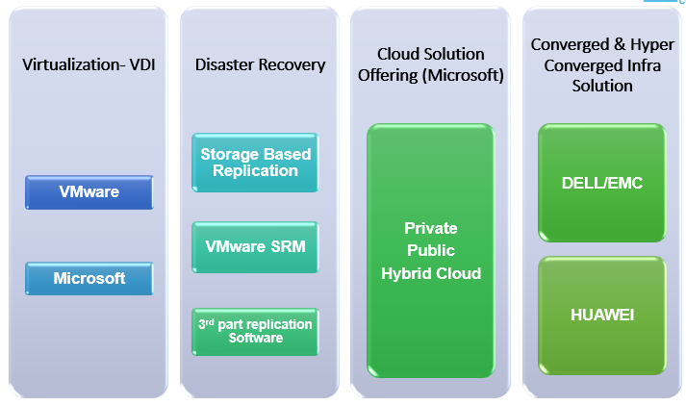

* **Networking and Security**

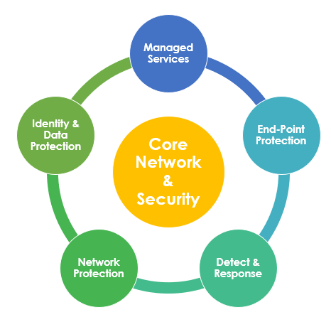

* **Digital Transformation**

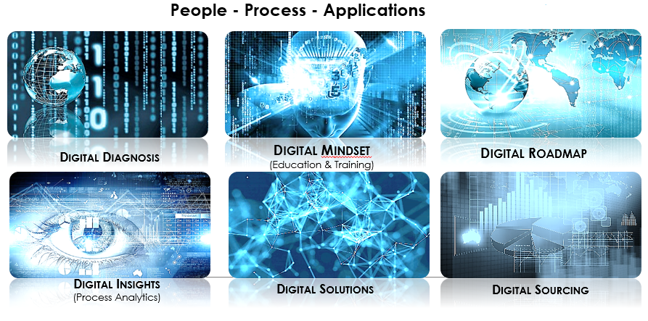

* **Application Consultancy and Support**

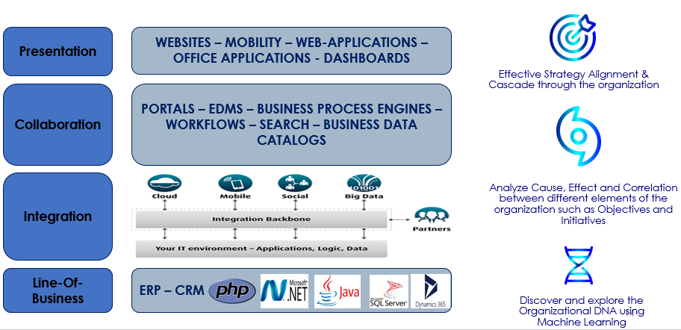

* **Workplace Collaboration**

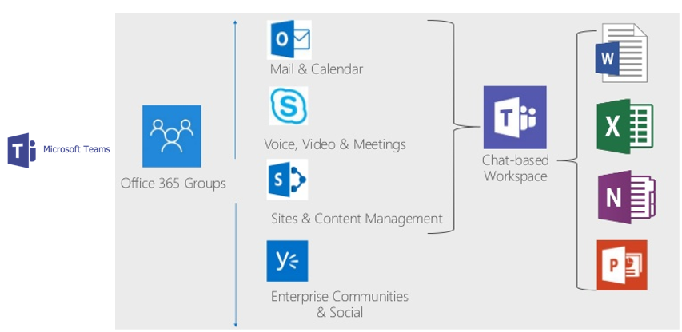

* **Integrated Workspace Management (CAFM)**

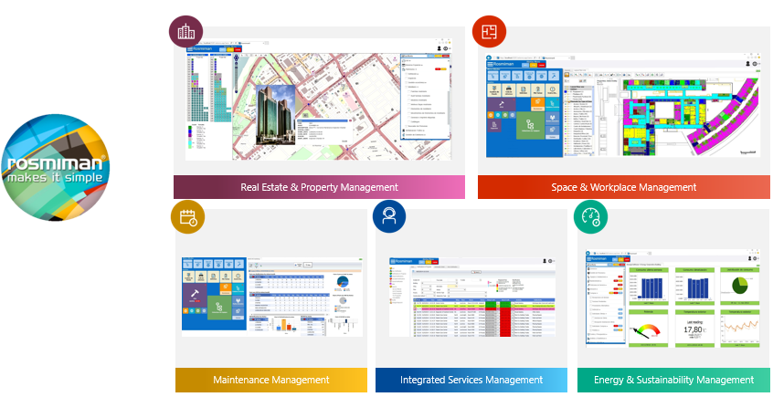

* **Analytics and BI**

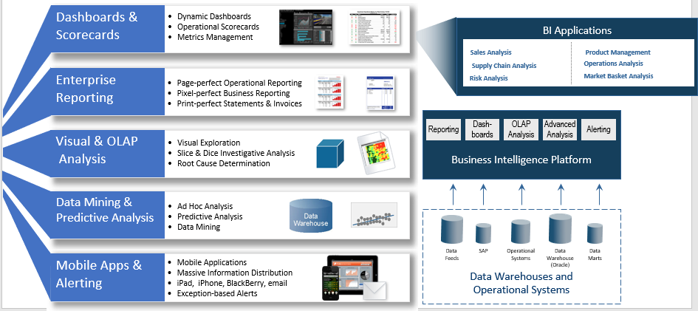

* **Microsoft Licensing, Consultancy & Support**

**Services Programs**

Accelerate Advisory, Cloud Operations, Technology Consulting, TAM (Technical Account Manager), Education and Certification, Disaster Recovery Advisory Solutions for Audit

**Assessment Programs**

Proof of Concepts, Health Assessment, Virtualization, SAM, Security, ERP, Content Management, CRM, Private Cloud Assessment, Hosting, Datacenter, Archiving, Data Housekeeping.

**Implementation Programs**

Virtualization Technology Solutions, Private Cloud Solutions, Active Directory, Identity Manager, Rights Management Services, Skype Gateway & Phones, VDI Solutions, Office 365 Solutions, Database Services, DR Solutions

**Licensing Programs**

* Government Enterprise Agreements
* School/CAMPUS Agreements
* CSP Agreements
* MPSA Agreements
* Enterprise Agreements



* **Cloud Platform Services & Consultancy**

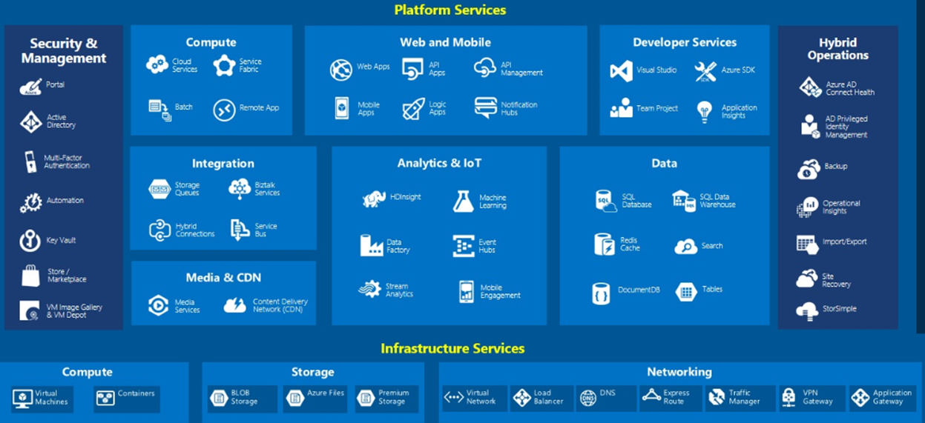

## **Profile – SECOND STEP:**

Second Step Software Development LLC (hereafter referred to as Second Step) is a leading software development company in UAE formed to serve strategic projects with key skills and expertise, provide Enterprise clients with world-class solutions addressing their local business needs.

Established in 2014, a specialized software development company in Education and Health. The vision is to become an international leader in value creation, knowledge and innovation, through investment in diverse industries which contribute to the UAE’s security and economic development.

Second Step is focused on customized product solutions. In 2014, it began to offer implementation services for government, and Education and healthcare management solutions, demonstrating real added value to customers. Second Step have established a Jordan development centre in an area with a highly skilled talent pool. This allows us to tap into a wealth of knowledge and exhibit elasticity for our clients in very competitive markets.

Second Step is aligned to the MOE vision and differentiates its services with the ability to plan, design, and implement technology solutions with the support of our technical team, who are trained and experienced in the development and implementation of customized software products. Second Step understands that the MOE business is dynamic and continually evolving and so Second Step has built a model and a partnership with the MOE in order to be agile and deliver fast. Second Step has built a dedicated team of highly skilled professionals and a set of competences that form the underpinnings of its competitive advantage.

## **Profile – ITWORX EDUCATION**

Originally part of ITWORX Ltd (founded in 1994 group), ITWorx Education is fully dedicated for serving education community by providing ready-made products and services that enables education authorities, K12 schools, Higher Education institutes, and corporations to realize their e-learning visions effectively and efficiently.

Following a 14+ years' experience in MENA and worldwide and efficiently part of the education transformation projects in two Ministries of Education, and repeatedly acknowledged by MS in the “Education Partner of the Year” award. ITWorx Education is now positioned as a leading education service provider.

### **ITWorx Education Solutions and Services:**

ITWorx Education offers a diversity of solutions and services varying from simple mobile applications and portals to complicated business intelligence and automated workflows' solutions.

**Ready-made Products**

|  |  |  |
| --- | --- | --- |
| Social Learning Space | * A SaaS social learning space that drivers learner’s engagement from school to higher education |  |
| PD Management | * Web-based solution to manage and monitor professional development |  |
| Classroom Management | * TeacherKit on Apple App Store, Google Play Store and Microsoft Windows Apps Store |  |

**Services**

|  |  |
| --- | --- |
| Professional Services | ITWorx Education has designed and implemented a variety of solutions for education customers including the following software professional services:   * Assessment automation * Internet as well as Intranet portals to address varying school, district and ministry objectives and visions * Content management portals * Integration with other systems (system integration approach) * Product White Labelling * Localization * Testing * Operations and maintenance |
| Consultancy | ITWorx Education has a strong consultancy / training arm which has added greatly to the success of its education projects:   * Change management * Adoption * Training * Mentorship |

|  |
| --- |
| IMPORTANT:   * Your LPO must refer/agree to or list the above listed terms and conditions in this quotation reference number: **OPP/2020/5/2772** * Please mention this reference number in all your future correspondence with us on this quotation. * Your LPO must highlight our payment terms. * Your LPO must be duly signed and stamped. |

**\*End-of-Document\***